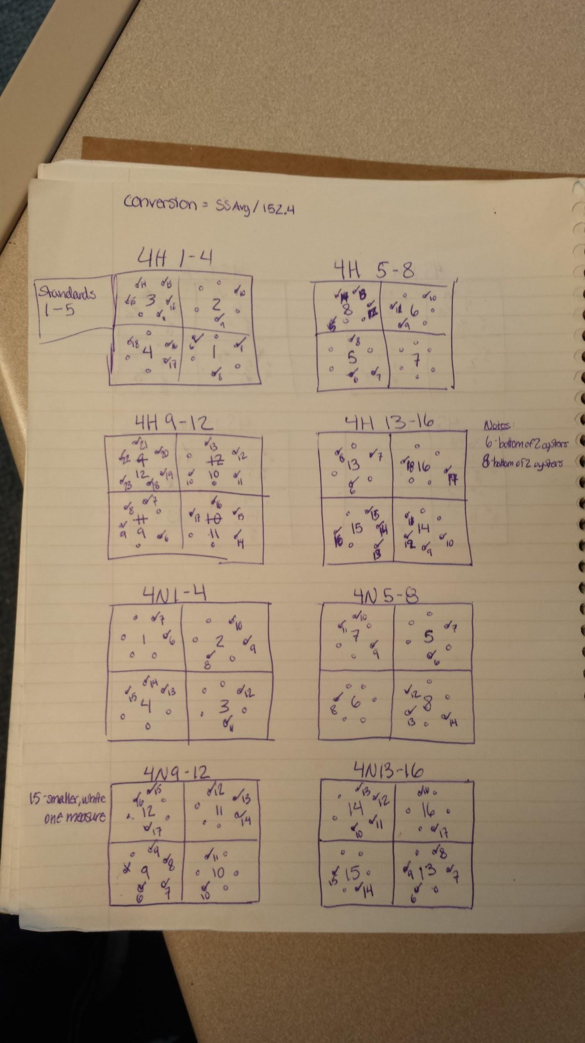
Manchester Tray 4H 1-4 to 4N 13-16. Final pictures aligned to beginning output pictures via aligning the numbers on the plates as well as the line orientation arrangement of the tiles. In ImageJ the measurements are numbered and our first 5 measurements are the standards so I began numbering oysters that I found on the final images 6 through however many present. I made small notes for myself on the side for trays that had oysters on it that did not belong and that I should not measure. Each tile began with 6 oysters illustrated by the small circles and a check mark was placed on the circle if the oyster was still present in the final image.

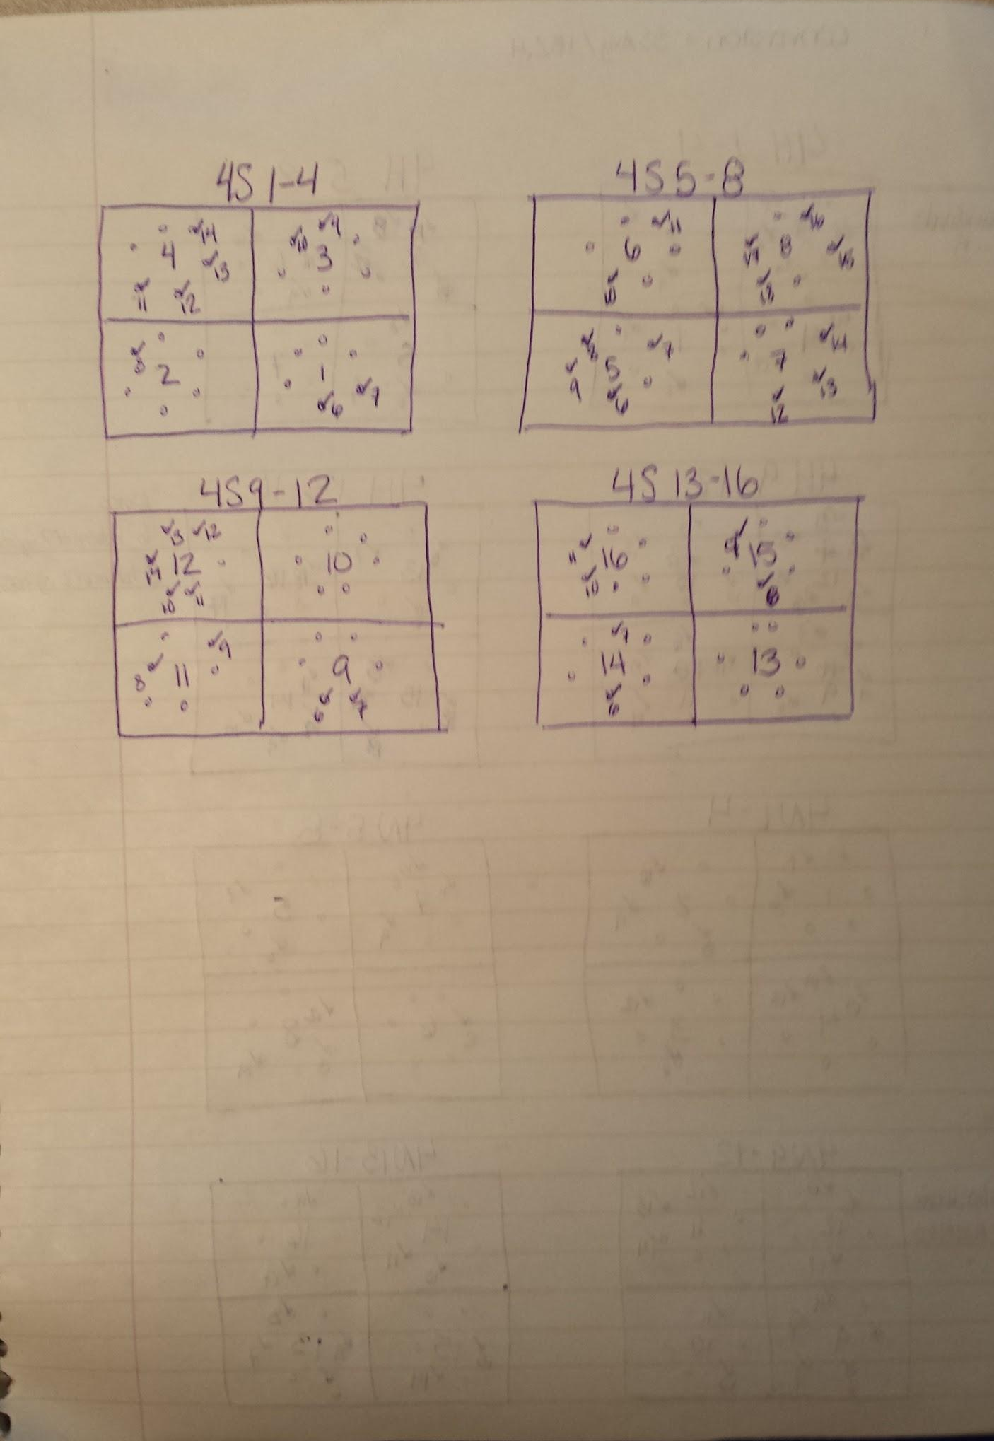
Manchester Tray 4S 1-4 to 4S 13-16. Final pictures aligned to beginning output pictures via aligning the numbers on the plates as well as the line orientation arrangement of the tiles. In ImageJ the measurements are numbered and our first 5 measurements are the standards so I began numbering oysters that I found on the final images 6 through however many present. I made small notes for myself on the side for trays that had oysters on it that did not belong and that I should not measure. Each tile began with 6 oysters illustrated by the small circles and a check mark was placed on the circle if the oyster was still present in the final image.
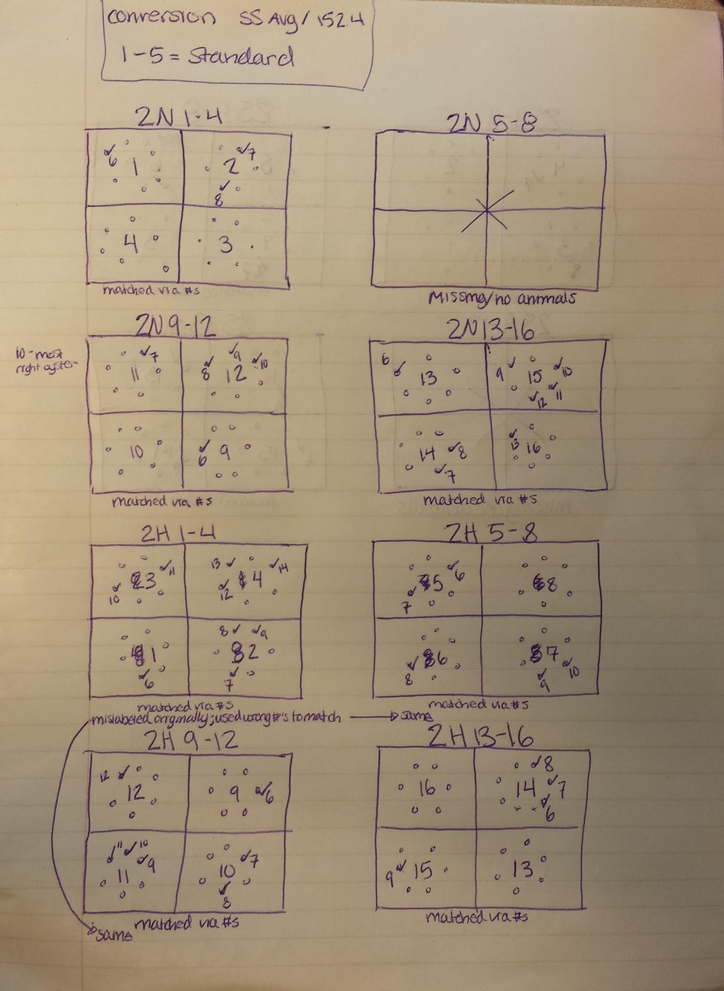
Fidalgo Bay Tray 2N 1-4 to 2H 13-16. Final pictures aligned to beginning output pictures via aligning the numbers on the plates as well as the line orientation arrangement of the tiles. Trays @h 1-4, 2H 5-8, and 2H 9-12 were mislabelled and the red writing was washed of when final study pictures were taken so incorrect numbers matched to original tile where they were crossed out to get correct orientation and matched the correct numbers from the original pictures to the final pictures. In ImageJ the measurements are numbered and our first 5 measurements are the standards so I began numbering oysters that I found on the final images 6 through however many present. I made small notes for myself on the side for trays that had oysters on it that did not belong and that I should not measure. Each tile began with 6 oysters illustrated by the small circles and a check mark was placed on the circle if the oyster was still present in the final image. Tray 2N 5-8 did not have any animals at the end of the study.
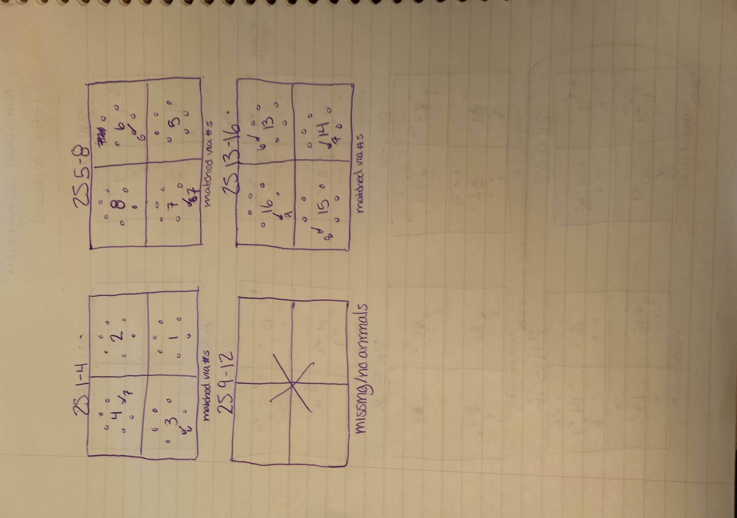
Fidalgo Bay Tray 2S 1-4 to 2S 13-16. Final pictures aligned to beginning output pictures via aligning the numbers on the plates as well as the line orientation arrangement of the tiles. In ImageJ the measurements are numbered and our first 5 measurements are the standards so I began numbering oysters that I found on the final images 6 through however many present. Each tile began with 6 oysters illustrated by the small circles and a check mark was placed on the circle if the oyster was still present in the final image. Tray 2S 9-12 did not have any animals at the end of the study.
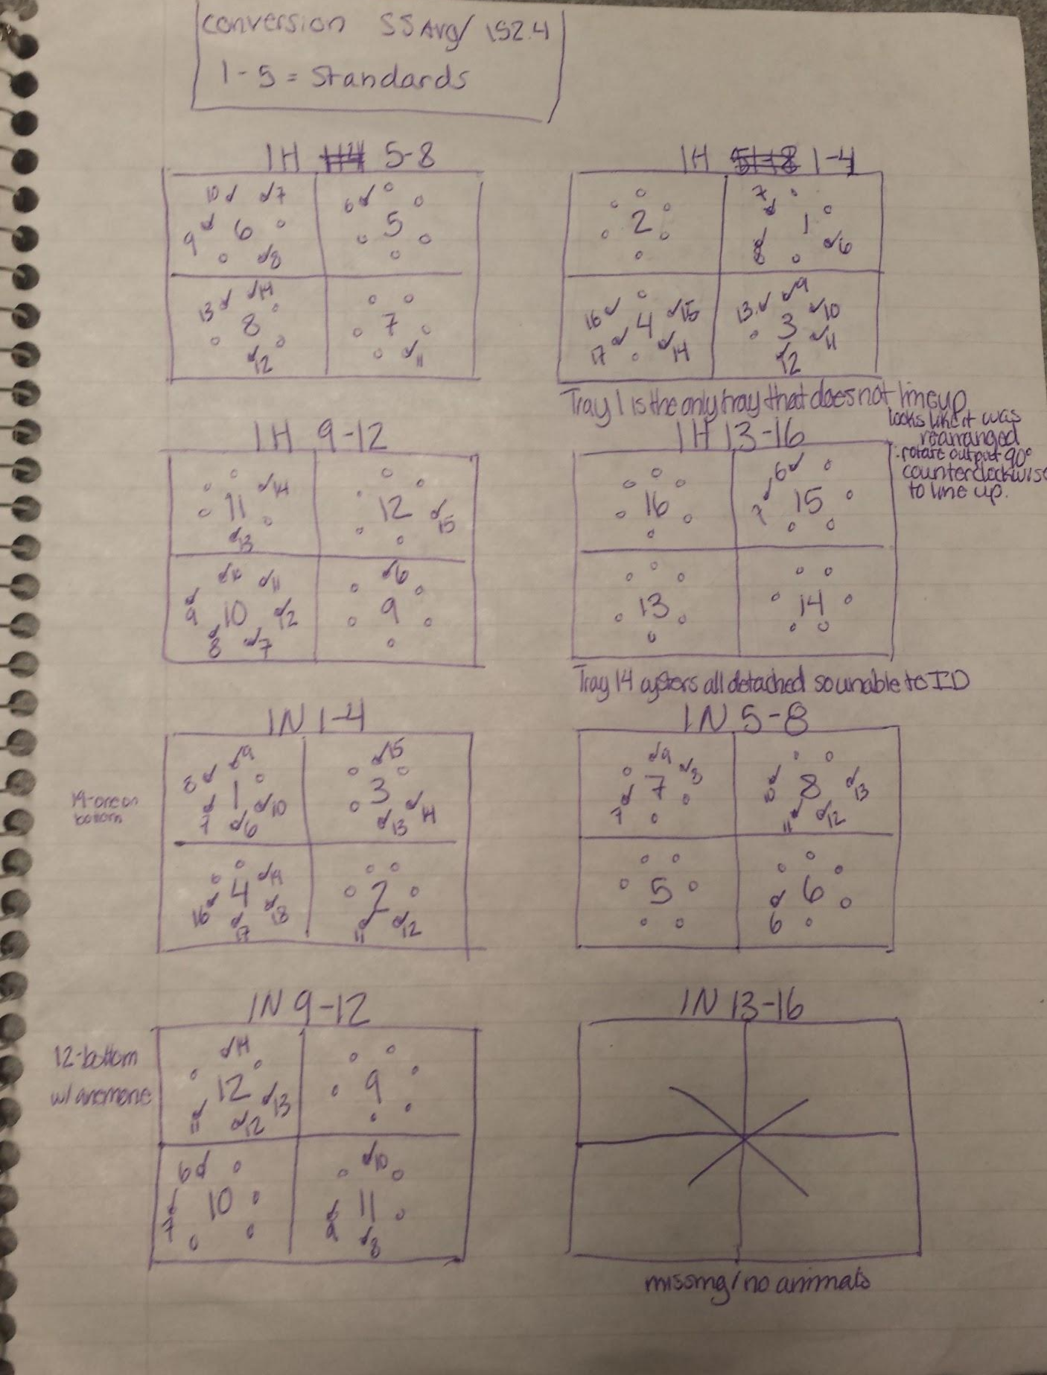
Oyster Bay Trays 1H 1-4 to 1N 13-16. In ImageJ the measurements are numbered and our first 5 measurements are the standards so I began numbering oysters that I found on the final images 6 through however many present. I made small notes for myself on the side for trays that had oysters on it that did not belong and that I should not measure. Each tile began with 6 oysters illustrated by the small circles and a check mark was placed on the circle if the oyster was still present in the final image. Tray 1H 1-4 was oriented via a dark black line on one of the tiles. Tray 1H 5-8 was aligned via matching the tile orientation as well as matching the orientation of the coding printed on the edge of each tile since no numbers were present after one year. 1H 9-12, 1H 13-16, 1N 5-8, and 1N 9-12 corrected numbers were washed off after one year but incorrect numbers that had been previously crossed out still remained so tray oriented using incorrect numbers and then matched to outplant to figure out correct tile labels. Tray 1N 1-4 matched via correct tile number orientation. 1N 13-16 did not have any animals present after one year so measurements were not taken. For tray 1H 1-4 on tile 1, the tile is the only one that did not line up and it appears that it was rearranged and rotated 90 degrees counterclockwise between the outplant and one year picture. Tray 1H 13-16 on tile 14 all oysters are detached and lined up so unable to ID original outplant oysters

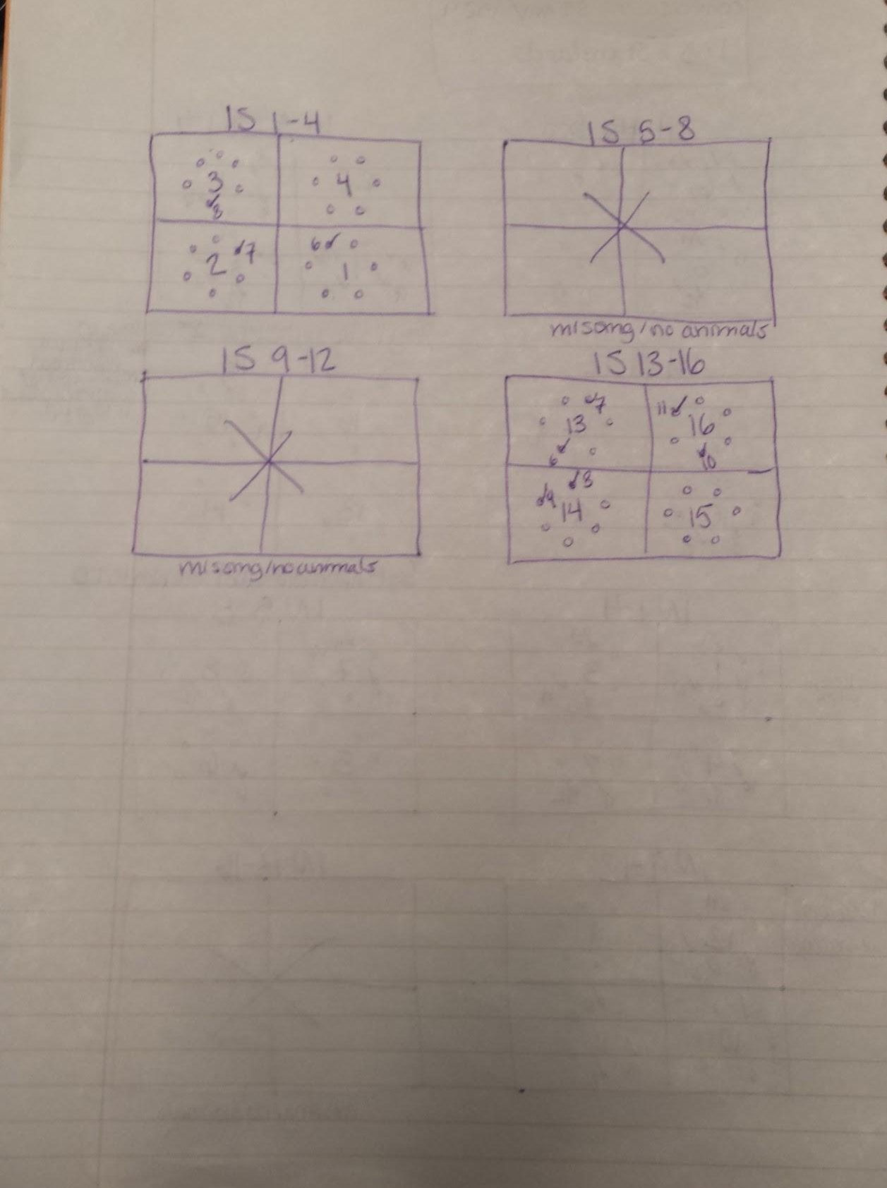
Oyster Bay Trays 1S 1-4 to 1S 13-16. In ImageJ the measurements are numbered and our first 5 measurements are the standards so I began numbering oysters that I found on the final images 6 through however many present. I made small notes for myself on the side for trays that had oysters on it that did not belong and that I should not measure. Each tile began with 6 oysters illustrated by the small circles and a check mark was placed on the circle if the oyster was still present in the final image. Tray 1S 1-4 matched via correct tile number orientation. Trays 1S 5-8 and 1S 9-12 did not have any animals present after one year so measurements were not taken. Tray 1S 13-16 was aligned via matching the tile orientation as well as matching the orientation of the coding printed on the edge of each tile since no numbers were present after one year.

